Greetings!

As one of the table hosts for the Pathway to the Rockies Council Scouting America’s "2025 Community Investment in Character Luncheon," I would like to personally invite you to join me for a hosted lunch and inspirational program featuring Denver Bronco Legend, Mark Jackson on May 7th, 2025, at Noon (Flying W Ranch). This is the Council’s foremost fundraising celebration and your financial investment will help instill values that will last a lifetime with the young people in the communities of Southern Colorado. Please RSVP your attendance to me by DATE at PHONE # or EMAIL ADDRESS. If you are unable to attend the lunch, please consider making a contribution to local Scouting by clicking the link below and type my name in the comments section followed by “for the 2025 Investment in Character Lunch.” Thank you in advance for making a difference in the lives of our young people. I look forward to hearing from you.

Click Here to Invest in Scouting

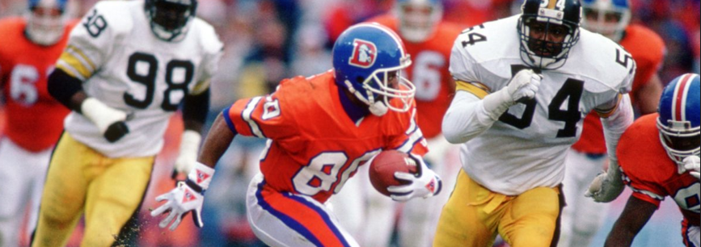

You’re Invited…

Cost: Fundraising event, Recommended contribution - $250 or more
Location: Flying W Ranch, 3330 Chuckwagon Road, Colorado Springs, CO 80919
Date and Time: May 7th, 2025 at Noon

Our Featured Speaker – Denver Bronco Mark Jackson
Mark spent 9 years in the NFL (7 in Denver) and was a member of the larger than life “Three Amigos”, alongside Vance Johnson and Ricky Nattiel from 1987-1989. Undoubtedly the most colorful of the trio, Mark possesses a smile that won’t quit and a huge heart to go with it. Beloved by Broncos fans, his big personality, toughness, and clutch moments would solidify him as a Broncos legend.

